Project Report on

**Car Rental System**

Masters of Computer Applications

SUMMER PROJECT

MCA Semester V

**Submitted By**

**AMEY BHIM RAO**

838 (T.Y.MCA)

MCA 2019-2020

**Mumbai Educational Trust’s**

**Institute of Computer Science**

# University of Mumbai

**CERTIFICATE OF APPROVAL**

This is to certify that the project report titled

**Car Rental System**

Is a Bonafide record of the work done by

**AMEY BHIM RAO**

**838**

MCA Semester V

Under the guidance of

Lavina Jadav

________________ ________________

Dr. Abhijit Banubakode Prof. Lavina Jadav

Principal Project Guide

MET’s ICS MET’s ICS

**CERTIFICATE OF APPROVAL**

This is to certify that the project report titled

**Car Rental System**

Is a Bonafide record of the work done by

**AMEY BHIM RAO**

838

This project is approved as summer project for

MCA Semester V

University of Mumbai

Examiner Examiner

Sign: _________ Sign: _________

Name: _________ Name: _________

Date: _________ Date: _________

# Acknowledgements

I would like to thank **Dr. Abhijit Banubakode**, Principal and **Mr. Lavina Jadav Madam**, project guide, who were a constant source of help and played an important role in the successful execution of this project.

**INDEX**

|  |  |  |
| --- | --- | --- |
| **SR. NO.** | **Module** | **Detailed Contents** |
| 1 | Introduction | * Introduction of Project * Problem Definition * Scope of Project |
| 2 | System Study | * Existing System * Proposed System * Use Cases |
| 3 | Analysis & Design | * Software Requirement Specification * DFD * Activity Diagram |
| 4 | User Manual | * Method of Implementation * Forms * Output Screens |
| 5 | Conclusion | * Project Conclusion * Future Enhancement |
| 6 | Bibliography | References used |

**INTRODUCTION OF PROJECT**

The main objective of the application car Rental System require a temporary vehicle, for example those who do not own their own car, or owners of damaged or destroyed vehicles who are awaiting repair or insurance compensation or travelers who are out of town.

**PROBLEM DEFINITION**

A new up and coming car rental service is wishing to have a user interface that will allow their customers to view the models, descriptions and prices of different cars available. The user has the ability to register and log in to the Web App and track their rental plan. The Web App will be responsive, allowing for the customer to view it on any device, from tablets to mobile phones and desktop computers. The administrator will also be able to login through the same form but have the ability to add/remove new car rentals, change prices, and so on. Potential customers should be able to view all the cars available to rent even without logging in as well as rent without having an account, though the option is provided upon checkout.

**SCOPE OF THE PROJECT**

1. Providing car catalog to the Users so that they can choose the best option based on their concern

2. Admin can manage the catalog by adding or removing the cars based on their availability and allows only authorized Users (Driver License) to rent a vehicle

3. Admin must make sure that the rented cars must have valid insurance.

4. Admin must allow user to provide feedback at the end of every ride.

**EXISTING SYSTEM**

In the present scenario the Rental Service owner keeps a paper book to keep track of user details. Manual processing of data is always time consuming and may commit more errors. There is much difficulty in allocating cars to the users. Further reference to the user details is time consuming. Accuracy of such data makes the system unreliable and inefficient. Obviously there is need of an efficient system. The proposed system rectifies the demerits and defects of the existing system to a greater extent.

**PROPOSED SYSTEM**

The Car Rental System which we design is in the same line of the existing system. No procedural changes are made to the existing system except the login process done by the customer’s .If any of the cars is not in working condition, there is facility to remove it from allocation process. After accomplishing the maintenance it can be added back to the Available Car List .When a new customer comes for browsing, an account is created for him. For Renting the car .Since information regarding the users is needed for further checking, an account can be deleted only after 5 years from the last login date. That is the information and details regarding usage of a user will be kept for at least 5 years.

**USE CASES**

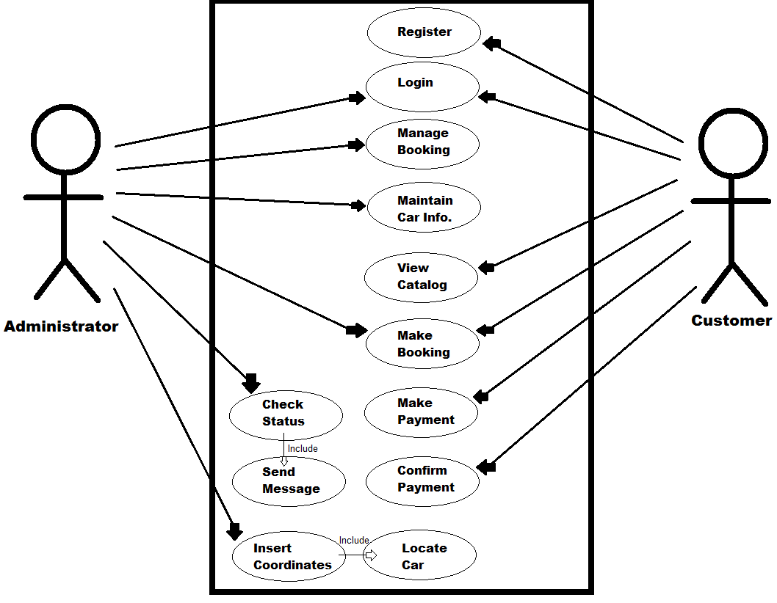

**SOFTWARE REQUIREMENTS SPECIFICATION**

Operating System : Windows 10 , 8, XP.

Front End : HTML , CSS , PHP , BOOTSTRAP.

Back End : MY SQL.

**ACTIVITY DIAGRAM**

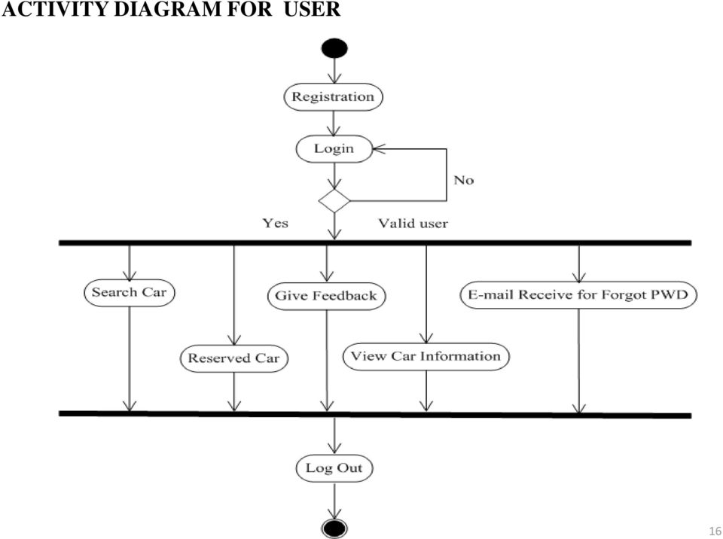

**DFD DIAGRAM**

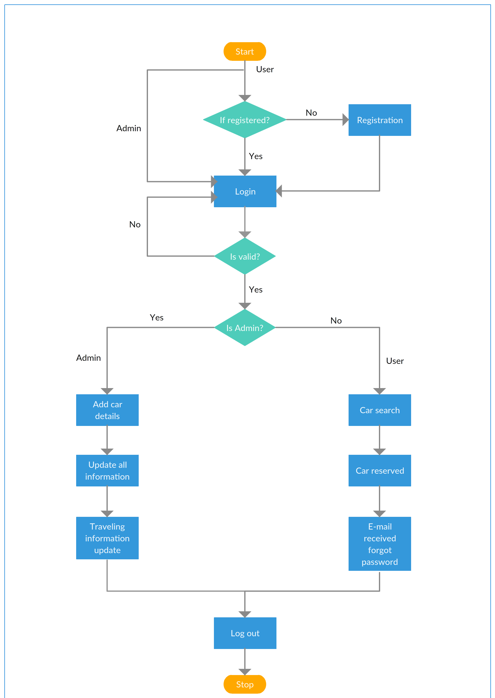

**METHOD OF IMPLEMENTATION**

* **Forms and Output Screens**

1. **Login Page**

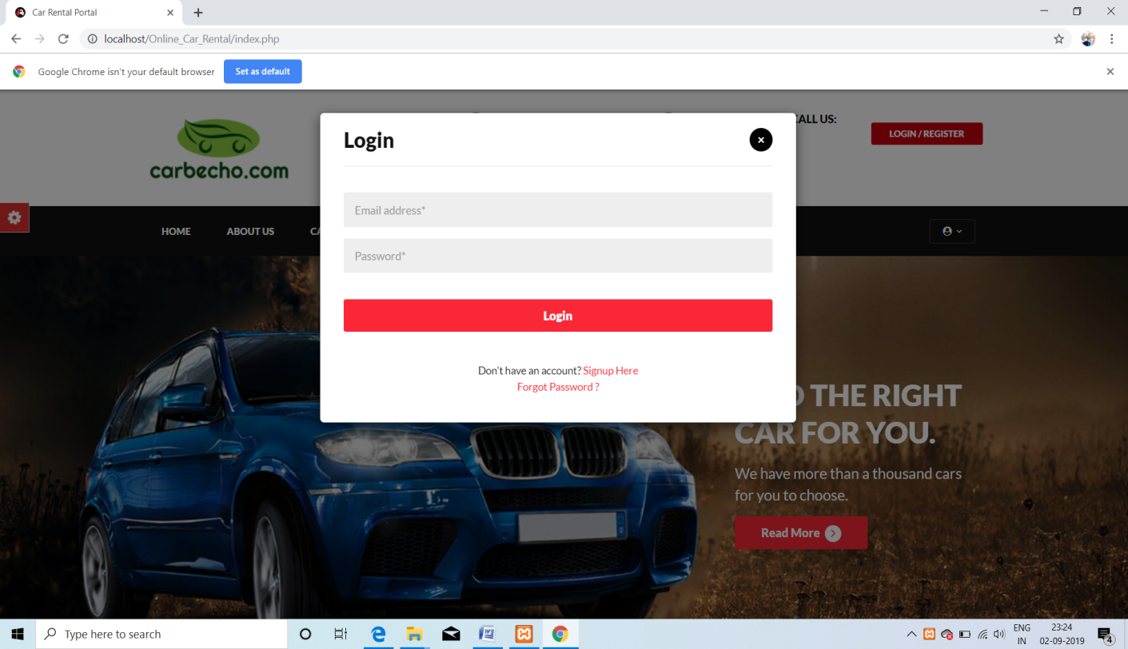

1. **Registration Page**

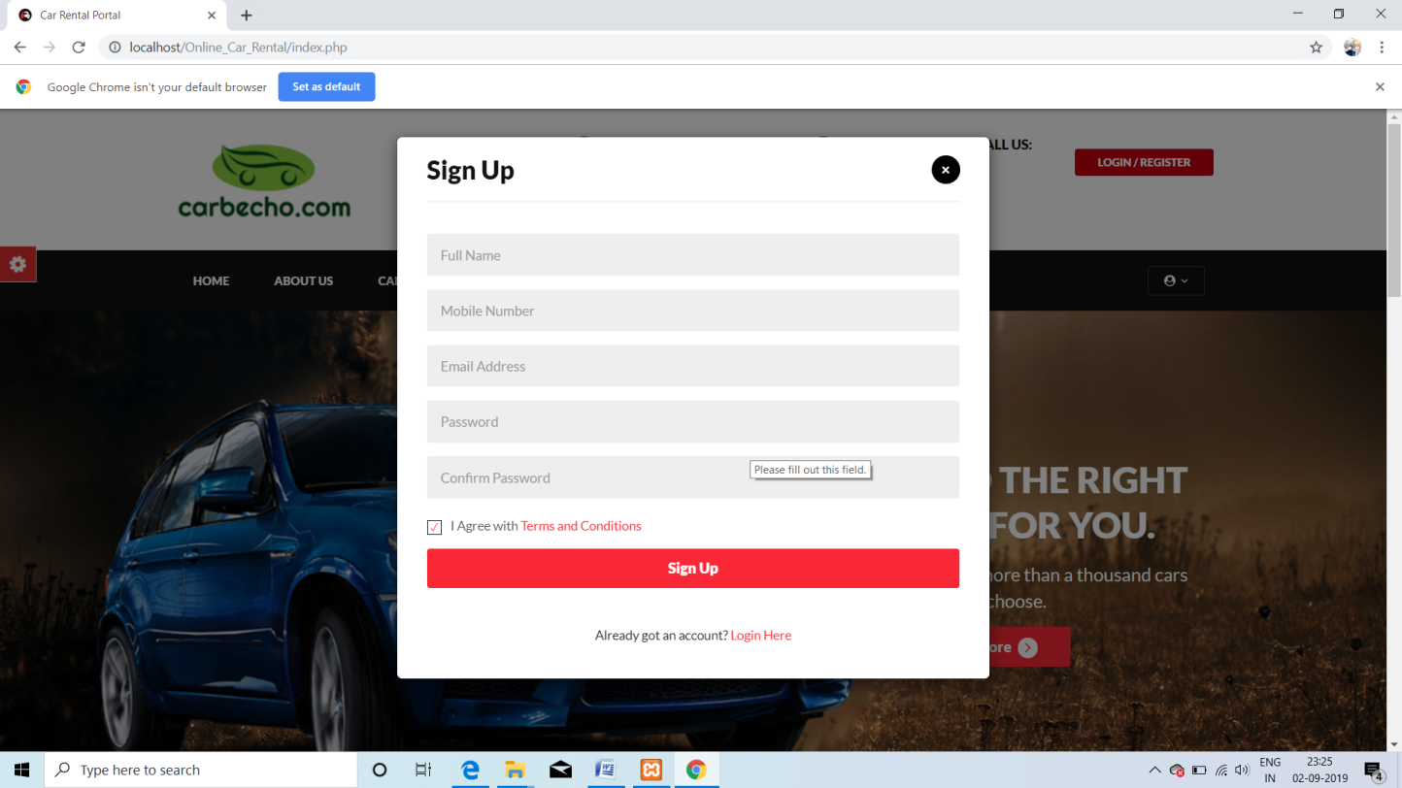

1. **Car Listing Page**

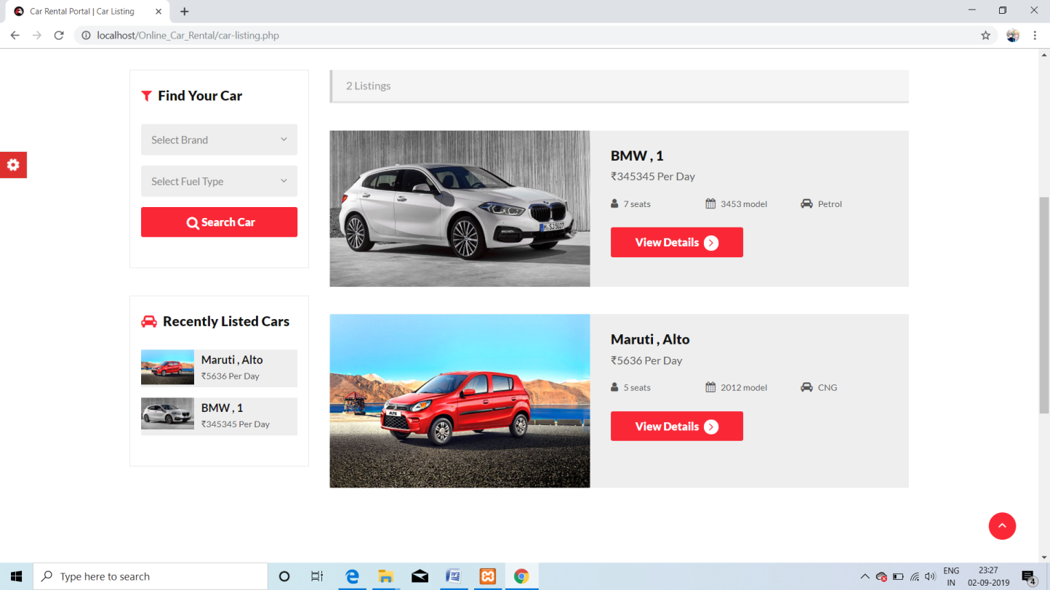

1. **Booking Page and Car Details Page**

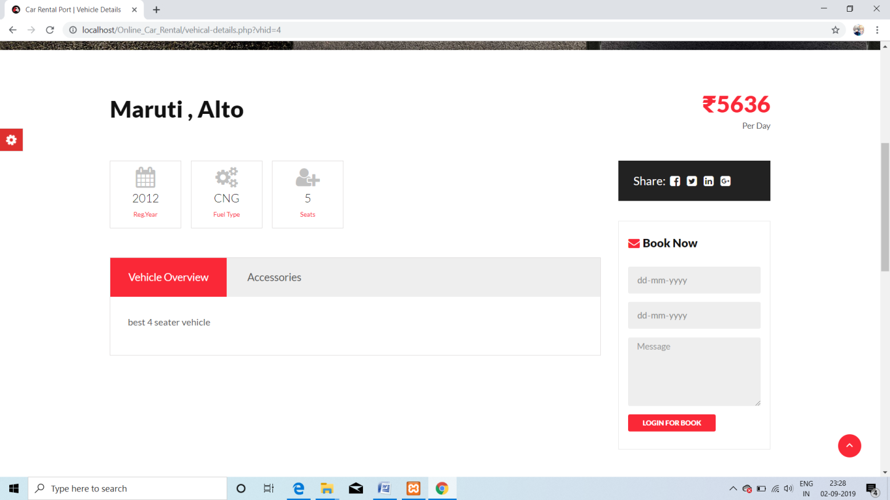

1. **Car Booked Page**

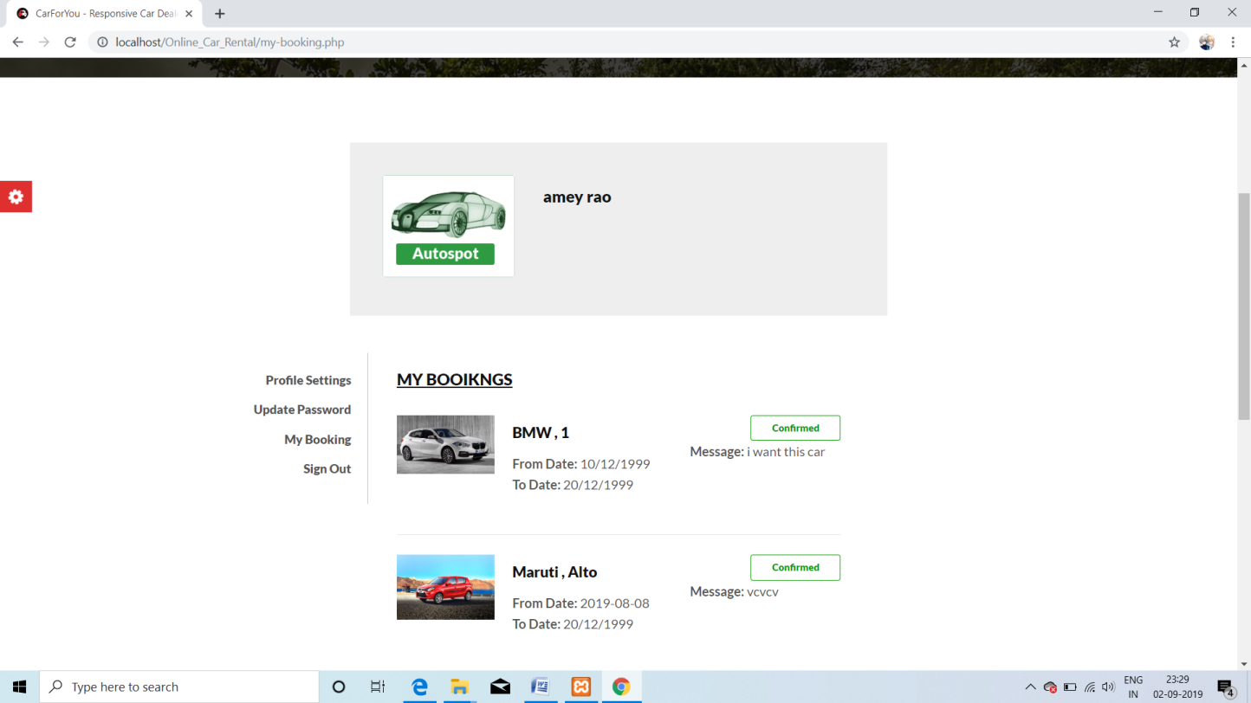

1. **Admin Login Page**

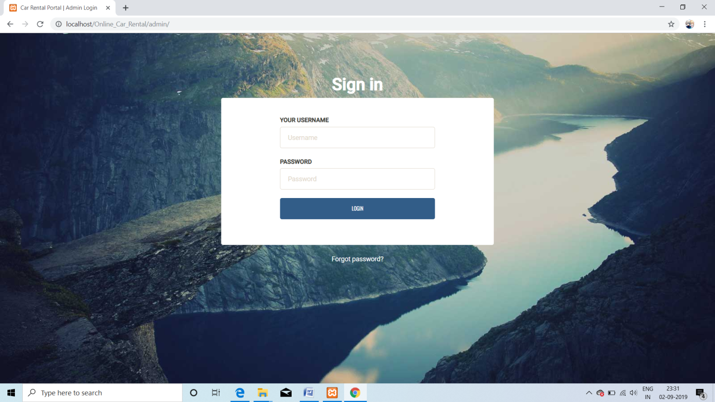

1. **Admin Dashboard**

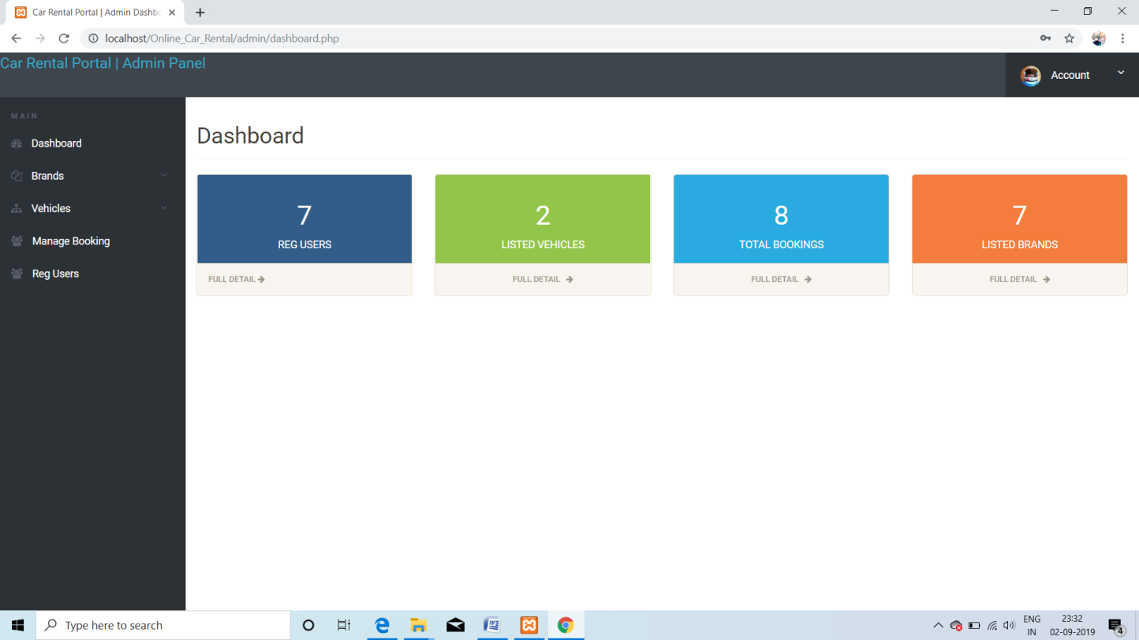

1. **Add New Cars**

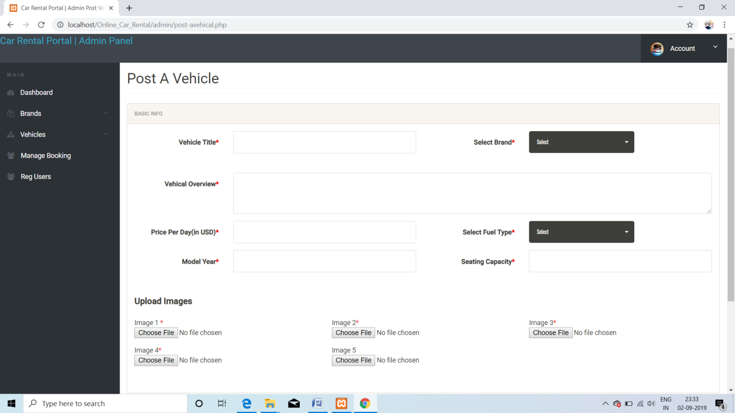

1. **Manage Cars**

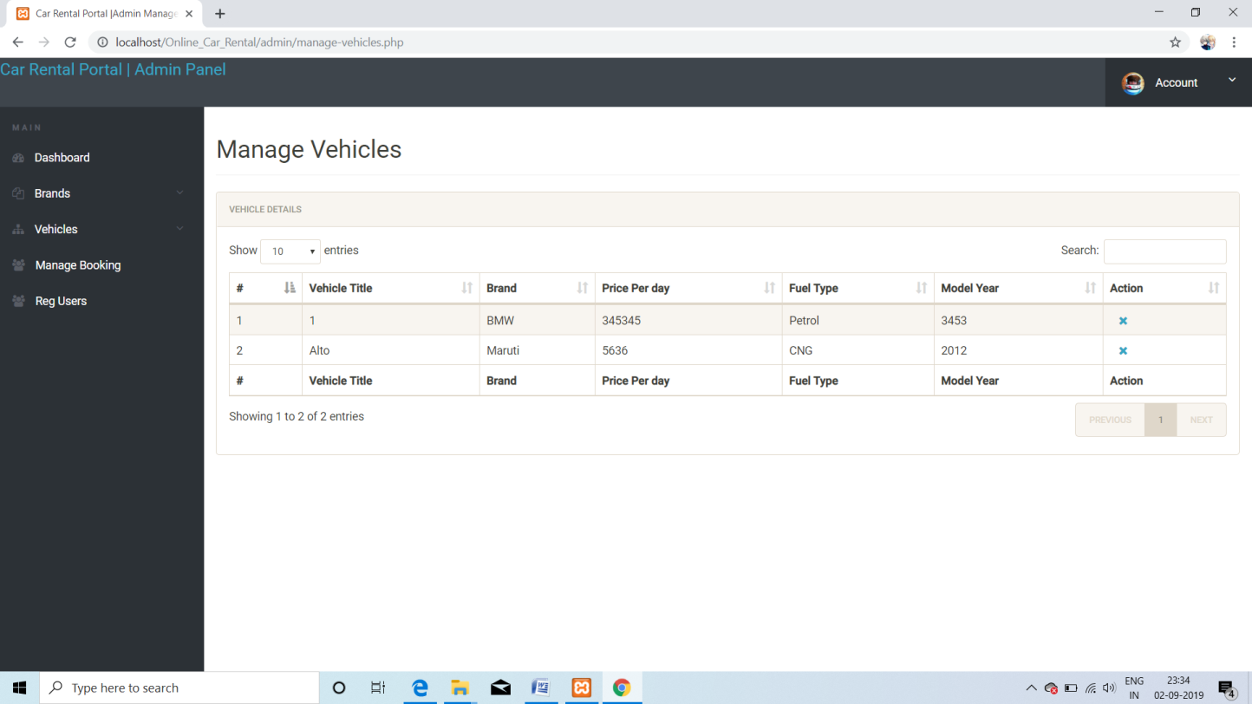

1. **Manage Booking**

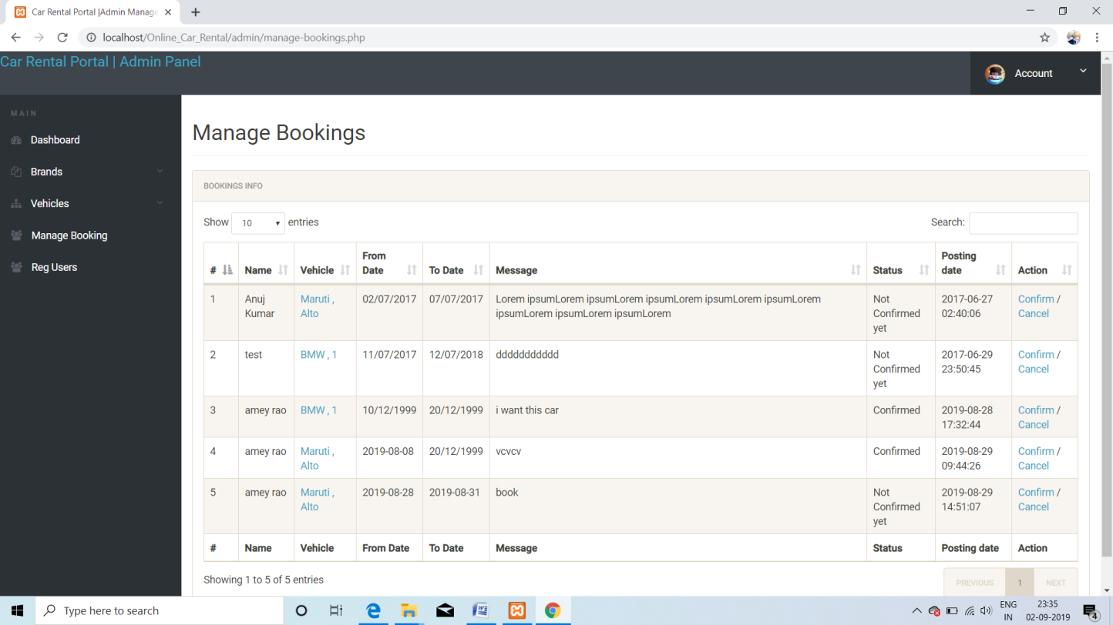

1. **Manage Users**

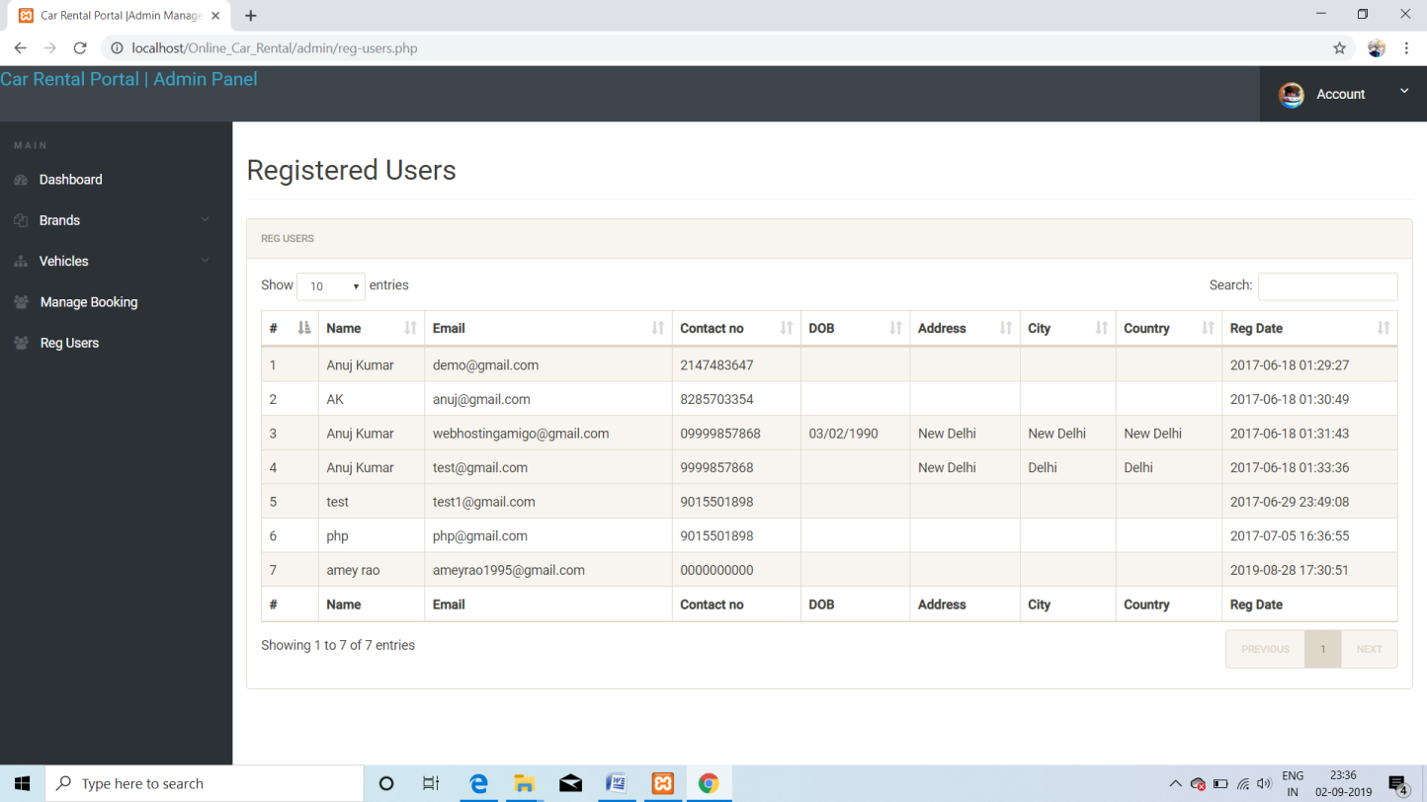

**FUTUREENHANCEMENTS**

We will try to make it more flexible and transparent by managing more number of user’s and cars.

We will try to restrict unauthorized person to use important data.Security on data can be implemented. As well as it can be converted into GUI platform.

All the works that are being held manually this software can do it very fast and in very less time.

**BIBLIOGRAPHY**

* [www.google.com](http://www.google.com)
* [www.w3schools.com](http://www.w3schools.com)
* [www.mysql.com](http://www.mysql.com)